Why is it so cold here?
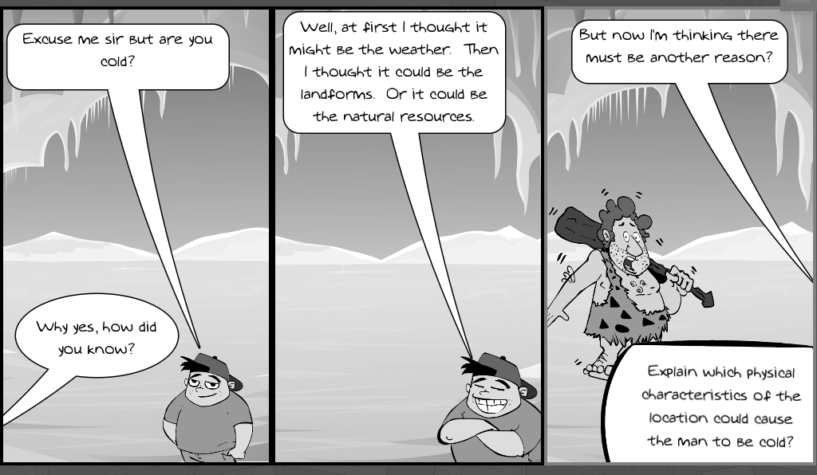
Look at the cartoon above to answer the questions below.
What is the main reason why the caveman is cold?

Which physical characteristics that the boy says could be reasons why it is a cold location?
Which physical characteristics could change during the year and affect the cold?

