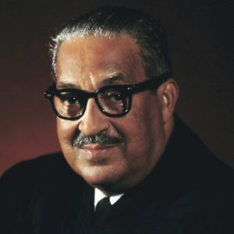  Thurgood Marshall | Date of Birth: Date they Died(if necessary):  Where from or area they influenced:  Interesting Heroic Deeds or Accomplishments:
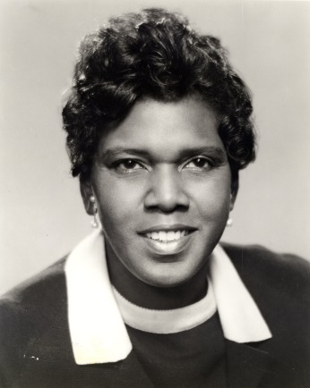  Barbara Jordan | Date of Birth: Date they Died(if necessary):  Where from or area they influenced:  Interesting Heroic Deeds or Accomplishments:
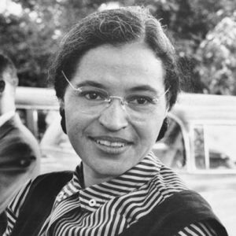  Rosa Parks | Date of Birth: Date they Died(if necessary):  Where from or area they influenced:  Interesting Heroic Deeds or Accomplishments:
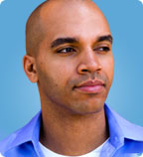  Kadir Nelson | Date of Birth: Date they Died(if necessary):  Where from or area they influenced:  Interesting Heroic Deeds or Accomplishments:
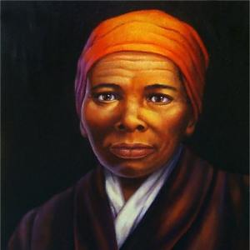  Harriet Tubman | Date of Birth: Date they Died(if necessary):  Where from or area they influenced:  Interesting Heroic Deeds or Accomplishments:
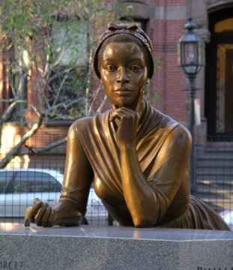  Phillis Wheatley | Date of Birth: Date they Died(if necessary):  Where from or area they influenced:  Interesting Heroic Deeds or Accomplishments:
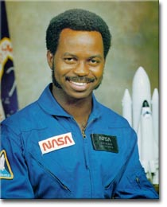  Ronald McNair | Date of Birth: Date they Died(if necessary):  Where from or area they influenced:  Interesting Heroic Deeds or Accomplishments:
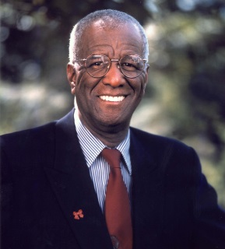  Wallace Amos | Date of Birth: Date they Died(if necessary):  Where from or area they influenced:  Interesting Heroic Deeds or Accomplishments:
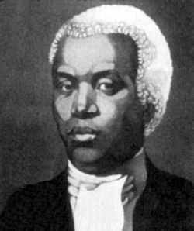  Benjamin Banneker | Date of Birth: Date they Died(if necessary):  Where from or area they influenced:  Interesting Heroic Deeds or Accomplishments:
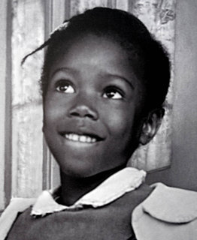  Ruby Bridges | Date of Birth: Date they Died(if necessary):  Where from or area they influenced:  Interesting Heroic Deeds or Accomplishments:

