Nothing to watch!!!!
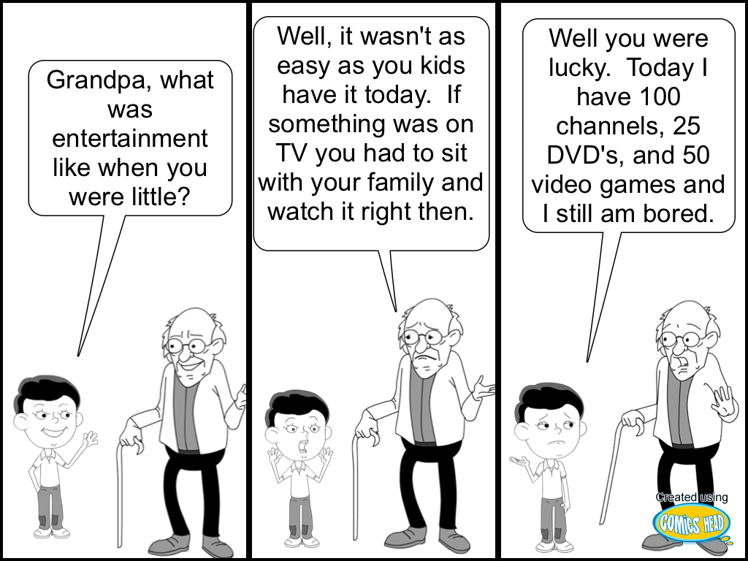
Look at the cartoon above to answer the questions below.
What technology is the grandpa referring to in the middle section?

Who do you think has an easier life when it comes to entertainment, the younger child or grandpa?
Describe a technology and how your life would be different without it that you use for entertainment.

