Model Lesson Plan

Course: Social Studies |  | Grade Level: 4th
Key Concepts / Skills: Reasons for exploration of North America and specifically Texas by Europe.
PRIMARY TEKS: 4.2A , 4.2B

Objectives:
(2) History. The student understands the causes and effects of European exploration and colonization of Texas and North America. The student is expected to:
(A) summarize motivations for European exploration and settlement of Texas, including economic opportunity, competition, and the desire for expansion;
(B) identify the accomplishments and explain the impact of significant explorers, including Cabeza de Vaca; Francisco Coronado; and René Robert Cavelier, Sieur de la Salle, on the settlement of Texas;
Materials/Resources:
Technology Material
Smartboard with microphone
Projector
Sample of Vodcast—if available
2 Vodcast Smart notebook templates (included below)
SMART Board Recorder Directions (included below)

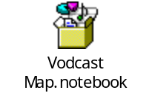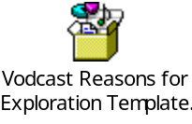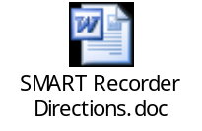

Classroom Materials
Vodcast Explorers Summaries (included below)—1 per group
Vodcast Explorer Map Storyboard (included below)—1 per group
Vodcast Explorer map and note page (included below—legal paper)—1 per student
or Vodcast Explorer Map and Notepage I-Chart (included below—legal paper)—1 per student
I-Chart—(included below)—1 per group
Color pencils—7 different if possible

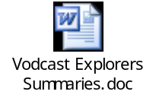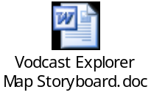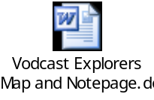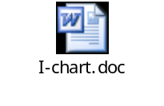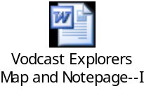
 | Procedures:
Thinking Level for Each Activity: | - Focus: Tell students that the United States has decided to establish a colony on a planet. Ask the students to brainstorm how they would decide which planet to live on and how they would gather that data if they knew nothing about any of the planets.  - Have students share their thoughts with a neighbor and then discuss as a class problems that they may run into. During this time direct the students towards the need to explore the area to be settled. Also bring in what could be reasons that the United States would want to establish a colony on another planet. Bring in resources, prestige, right to make their own society “better”. This will help connect the students with the idea of God, Gold and Glory later in the lesson.  - Activities: Day One  - After completing the focus (10 minutes), explain to the students that they will be researching about reasons for exploration of Texas, the areas that European countries settled in, and who came to explore Texas and what they accomplished.  - Have a student show where France, England, and Spain are on a map. Direct the students to see that the 3 countries were close together and that they have limited space and climate to grow certain crops or minerals so exploration and colonization became important.  - Divide the class into 6 groups. Each group will be responsible for creating a 1-3 minute Vodcast about their topic. The 6 groups are outlined below along with jobs for each group.  - Group 1—Reasons for Exploration  - Group 2—Areas of Settlement  - Group 3—Columbus  - Group 4—de Vaca  - Group 5—Coronado  - Group 6—de la Salle  Main job responsibilities in each group  - Director—responsible for making the storyboard and seeing that all required information is included.  - Narrator—reads the information to the computer during the Vodcast.  - Animator—responsible for moving and doing things on the Smartboard during the presentation.  - Producer—working Smartboard equipment, starting and stoping the recording, saving the recording by the correct name and to the correct location.  - All students will assist in creating the script and in the research. The animator role can be divided into multiple roles if it is necessary to have more then 4 students in a group.  - Each group should receive their corresponding summary, a sample of the map or chart they would use, and I-chart and the directions for that summary. The attachment is set to print so that each groups packet is compiled. The Reasons for Settlement group receives a snapshot of their Notebook screen and not the Map so that they can see what they will be presenting on.  - For the remainder of Day 1 the students will break into their group and read the summary and their textbook to complete the I-Chart. Depending on how familiar students are with I-Charts it may be necessary to do a sample with the students. An I-chart for the Smartboard is in the materials section or an overhead of an I-Chart can be made.  Day 2  - Depending on how far along the students are in their research the teacher may want to do a shared writing activity with them using a sample I-Chart.  - The director uses the story board to outline what will happen during their presentation. The teacher should explain that they will only have one “slide” to work with and all information must fit on that slide. Also student will need to write neatly so that other students can read their writing.  - Students will use the remaining portion of the day to work on their scripts and practice their presentation. Remind the Director that they need to be sure all required information is in their presentation.  Day 3—depending on the class day 3 may not be needed.  - Students will use the bulk of this day to finish their storyboard and practice their presentations. If possible to have a working Smartboard in the room the teacher may choose to allow students to rotate through to it so that they can practice on it before they actually record their presentation.  - Teacher should use this time to spot check each groups presentation for accuracy and to be sure all required information is there.  - Students should be told that they can use notecards since they won’t be seen on camera, only heard.  Day 4  - Using the Smartboard and the SMART Recorder students will record and present their information.  - Teacher may choose to have students record their presentation in front of the class or in a separate place so that students will only hear the information for the first time when they watch the Vodcast.  - ITS can assist with this part but please refer to SMART Recorder directions for more detailed directions.  - The most important part is being sure that the students save their Vodcast correctly. If students will be viewing Vodcasts from other classes then you may want to include the teachers name in the title. Below are the recommended titles. The parts in BOLD would be the most necessary and the parts after would depend on what was to be done with the Vodcast.  Samples: Name of presentation—School—Teacher/Grade/Subject/Class  - Reasons for Exploration—OLE—4th grade--PM  - Areas of Settlement—OLE—SS--AM  - Columbus—OLE—Smith—4th—SS—PM--FBISD  - de Vaca--OLE  - Coronado--OLE  - de la Salle--OLE  Day 5—in computer lab, workstations or as a whole group  - Pass out the Explorer Maps and Note page. Explain to the students that the purpose of a Vodcast is to share information. The teacher may choose between the simple Note page or the one with I-Charts. If a campus uses the one with I-Charts then they will need to watch more then one Vodcast on each topic.  - If in a computer lab direct students to the location of the Vodcasts and have the students watch the first Vodcast. This is where a class may watch theirs or another schools depending on how the lesson was set up. Then have them complete their information on their note page.  - Have the students watch the rest of the Vodcast’s. Have them watch the Vodcast straight though once then rewind to parts they don’t understand or watch and pause as they complete their notes.  - Take care that students draw the routes on the maps correctly. If they don’t have different colors then it may be necessary to walk students through how to use dotted and dashed lines to show the different routes.  - After completion of Vodcast’s the class may want to review as a whole each cast to see if they are missing any information of their notes.
Assessment Options :
Have students create a graphic organizer showing the accomplishments of each of the explorers and how they impacted the settlement of Texas.

Have students create a diary entry from the viewpoint of someone on one of the expeditions who has never sailed on a boat before.

Have students create a foldable showing the reasons for exploration of each of the three countries.

Extensions:

